Lab: Remote Spark with Livy

November 30th, 2017

Author: Elena Lowery elowery@us.ibm.com
Table of contents
Contents
Overview 1
Required software, access, and files 1
Part 1: Configure Livy in HDP 1
Part 2 : Review sample notebooks 1

Overview
In this lab you will learn how to configure Hortonworks Data Platform (HDP) for remote Spark execution with Livy and run sample DSX Local notebooks.
For more information, please see Hortonworks documentation: https://docs.hortonworks.com/HDPDocuments/HDP2/HDP-2.6.1/bk_spark-component-guide/content/ch_submit-spark-apps-livy.html

Required software, access, and files
- To complete this lab, you will need access to a DSX Local cluster and HDP.

Part 1: Configure Livy in HDP

- If you’re running this lab in an IBM environment, verify that Livy has been configured: https://ibm.box.com/s/6srzqmpw9wc6y2hrasskblibwusf5ia9

Part 2 : Review sample notebooks

- Log in to DSX and open the dsx-samples project.

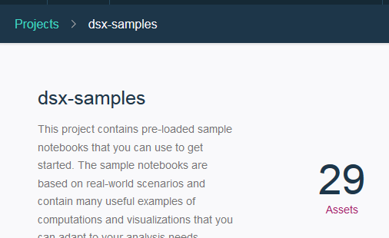

- Find the three remote Spark execution notebooks.

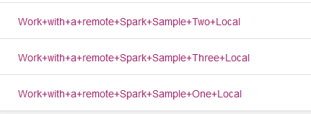

- Work through each notebook.

